Assignment Title: The economics of a climate-adapted community food system on Saibai Island.  
Student name: Yaofeng Yu  
Student number: 25213935  
Tutorial Class: Thursday 6-9pm  
Project opportunity: Project Opportunity: Design a climate-adaptive community food system on Saibai Island, enhancing local food security through low-cost, low-maintenance water and energy management practices. This must comply with Tasmanian Island Resource Council (TSIRC) planning and biosecurity regulations while respecting local cultural traditions.

**Research question**

Under local electricity, water and biosecurity conditions, how much could Saibai households save on food costs if locally grown fresh produce replaced some imported goods affected by freight disruptions?

**Introduction**

This paper outlines the economic case for import replacement within the Saibai food system – replacing a portion of high-freight imported fresh produce with locally grown agricultural products, thereby retaining more household expenditure on the island. This paper synthesizes local planning (TSIRC), regional freight evidence (TCICA), national price surveys, climate and biosecurity conditions (BOM/DAFF), and the isolated grid status (Ergon/AER) to reveal current areas of capital outflow and how even modest local production would alter the baseline.

**Planning and Land Risks**

Saibai is low-lying and prone to flooding. The Saibai Island Main Plan requires new community developments to consider flood risks, access routes, and service constraints, coordinating with the Council and landowners (TSIRC, 2024). From an economic perspective, this rationalizes upfront budgeting (site inspection, drainage, and flood access routes), thereby reducing projected losses from damage or rework over the asset's lifespan. Therefore, site selection and access routes form part of the fundamental economic benefits, rather than optional extras.

**Freight charges, pricing, and the importance of replacing imports**

Remote islands rely on barges and tidal/weather windows. The Torres Strait Indigenous Council Alliance (TCICA) freight balancing study indicates that factors such as long-distance transport, heavy handling steps, and shipping interruptions drive up delivery costs and create risks of goods shortages, including fresh produce (TCICA, 2023). In this context, even purchasing small quantities of local produce weekly can mitigate losses during delays and retain household expenditure that would otherwise be lost to off-island purchases via freight.

National-level efforts are also moving in the same direction. House of Representatives investigations revealed prices in remote Aboriginal and Torres Strait Islander communities significantly exceeded those in urban areas. The government response (NIAA, 2021) acknowledged affordability and supply issues while supporting enhanced regulation. This facilitates tracking price mitigation and expenditure retention rates—particularly when locally sourced produce is used to replace items in the commodity basket (House of Representatives, 2020; NIAA, 2021).

Consumer evidence clearly reveals the disparity. (CHOICE, 2024) reports that shopping basket prices in some remote Indigenous stores exceed urban levels by more than double; (ABC News, 2024) summarizes recommendations calling for strengthened regulation or implementation of essential goods safeguards. Though not core datasets, these reveal the pressures borne by households and the potential benefits of shortening local supply chains. (CHOICE, 2024; ABC News, 2024)

**Electricity, water and operational boundaries**

Saibai operates an independent microgrid. Ergon Energy manages numerous isolated or remote power stations. Electricity supply must be both secure and cost-effective, yet generation remains predominantly reliant on diesel, which is costly. The Australian Energy Report (AER) indicates that 33 isolated power stations serve 39 communities, primarily relying on diesel generation (Ergon Energy; AER, 2025). For community food supply initiatives, all electricity consumption—water pumps, lighting, small cold stores—must be tailored to local conditions. Power outages also introduce risk premiums. Interruptions limit the weekly amount of electricity that can be replaced.

Water resources are also critical. Horn Island data indicates a warm climate year-round with substantial monsoon rainfall. This wet-dry seasonal pattern influences required storage and processing volumes, as well as cost depreciation timelines. In short: projected yields and cost per kilogram will be subject to seasonal fluctuations. Please factor this into your budget planning. (BOM, 2025)

**Biosafety and Compliance**

Because of the proximity of Saibai to Papua New Guinea, the movement of plants, seeds, soil and boats is governed by the Biosecurity Act 2015 and the Northern Territory Quarantine Strategy. The Department of Agriculture, Fisheries and Forestry and Aquaculture (DAFF) establish rules governing the movement of goods into, out of, and within the Torres Strait, as well as shipments destined for the Torres Strait. It also oversees vessel/yacht transport from biosecurity zones to the mainland. Compliance requires permits, health certificates, and simple documentation. These costs are minor and predictable, helping avoid substantial losses from invasive pests and diseases. They should be regarded as operational expenditure with insurance value in any planning. (DAFF, 2023-2025)

**Conclusion**

On Saibai Island, the primary drivers are evident: freight-driven price increases, electricity costs and outages stemming from an isolated grid, wet and dry water measures, mandatory biosecurity protocols, and rising shelf prices at remote shops. These factors elevate the cost and risk of importing fresh produce. because of this, even modest, stable local output can sustain residents' expenditure and minimize losses during vessel delays – provided operations comply with local electricity/water constraints and biosecurity regulations.

**References**

**Torres Strait Island Regional Council. (2024). *Saibai Island Master Plan*.** [**https://tsirc.qld.gov.au/wp-content/uploads/2024/12/Saibai-Island-Master-Plan.pdf**](https://tsirc.qld.gov.au/wp-content/uploads/2024/12/Saibai-Island-Master-Plan.pdf?utm_source=chatgpt.com) **[Sourced from Partner]**

**EWB Challenge. (2025). *Saibai Island, TSIRC — challenge overview*.** [**https://ewbchallenge.org/challenge/saibai-island-tsirc/**](https://ewbchallenge.org/challenge/saibai-island-tsirc/?utm_source=chatgpt.com) **[Sourced from EWB/Canvas]**

**Engineers Without Borders Australia. (2024, June 17). *Navigating the tides: Saibai Island’s battle against climate change*.** [**https://ewb.org.au/blog/2024/06/17/navigating-the-tides-saibai-islands-battle-against-climate-change/**](https://ewb.org.au/blog/2024/06/17/navigating-the-tides-saibai-islands-battle-against-climate-change/?utm_source=chatgpt.com) **[Sourced from EWB]**

**Torres Cape Indigenous Council Alliance. (2023). *Far North Queensland freight equalisation study*.** [**https://tcica.com.au/wp-content/uploads/2023/02/tci1241_freight-equalisation-study-final.pdf**](https://tcica.com.au/wp-content/uploads/2023/02/tci1241_freight-equalisation-study-final.pdf?utm_source=chatgpt.com)

**House of Representatives Standing Committee on Indigenous Affairs. (2020). *Report on food pricing and food security in remote Indigenous communities*.** [**https://www.aph.gov.au/Parliamentary_Business/Committees/House/Former_Committees/Indigenous_Affairs/Foodpricing/Report**](https://www.aph.gov.au/Parliamentary_Business/Committees/House/Former_Committees/Indigenous_Affairs/Foodpricing/Report?utm_source=chatgpt.com)

**National Indigenous Australians Agency. (2021, December 2). *Australian Government response to the House of Representatives Standing Committee on Indigenous Affairs report: Inquiry into food pricing and food security in remote Indigenous communities*.** [**https://admin.niaa.gov.au/sites/default/files/documents/publications/final-govt-response-HORSCIA-report.pdf**](https://admin.niaa.gov.au/sites/default/files/documents/publications/final-govt-response-HORSCIA-report.pdf?utm_source=chatgpt.com)

**Bureau of Meteorology. (2025). *Climate statistics: Horn Island (Site 027058)*.** [**https://www.bom.gov.au/climate/averages/tables/cw_027058.shtml**](https://www.bom.gov.au/climate/averages/tables/cw_027058.shtml?utm_source=chatgpt.com)

**Department of Agriculture, Fisheries and Forestry. (2025). *Moving goods from, within and to Torres Strait*.** [**https://www.agriculture.gov.au/biosecurity-trade/policy/australia/naqs/moving-goods-torres-strait**](https://www.agriculture.gov.au/biosecurity-trade/policy/australia/naqs/moving-goods-torres-strait?utm_source=chatgpt.com)

**Department of Agriculture, Fisheries and Forestry. (2023). *Shipping and yachting in Torres Strait*.** [**https://www.agriculture.gov.au/biosecurity-trade/policy/australia/naqs/torres-strait**](https://www.agriculture.gov.au/biosecurity-trade/policy/australia/naqs/torres-strait?utm_source=chatgpt.com)

**Ergon Energy. (n.d.). *Isolated & remote power stations*.** [**https://www.ergon.com.au/network/our-network/isolated-and-remote-power-stations**](https://www.ergon.com.au/network/our-network/isolated-and-remote-power-stations?utm_source=chatgpt.com)

**Australian Energy Regulator. (2025). *Ergon Energy ring-fencing waiver: Isolated networks*.** [**https://www.aer.gov.au/industry/networks/ring-fencing/ergon-energy-ring-fencing-waiver-isolated-networks-2025**](https://www.aer.gov.au/industry/networks/ring-fencing/ergon-energy-ring-fencing-waiver-isolated-networks-2025?utm_source=chatgpt.com)

**CHOICE. (2024, October 31). *Groceries cost more than twice as much in some remote First Nations communities*.** [**https://www.choice.com.au/about-us/media/media-releases/2024/october/groceries-cost-more-than-twice-as-much-in-some-remote-first-nations-communities**](https://www.choice.com.au/about-us/media/media-releases/2024/october/groceries-cost-more-than-twice-as-much-in-some-remote-first-nations-communities?utm_source=chatgpt.com)

**ABC News. (2024, October 31). *Calls for food price cap in remote communities after essentials found to cost double*.** [**https://www.abc.net.au/news/2024-10-31/remote-grocery-prices-double-metro-calls-for-essential-item-cap/104537708**](https://www.abc.net.au/news/2024-10-31/remote-grocery-prices-double-metro-calls-for-essential-item-cap/104537708?utm_source=chatgpt.com)

**Appendix 1: Sources**

**Torres Strait Island Regional Council**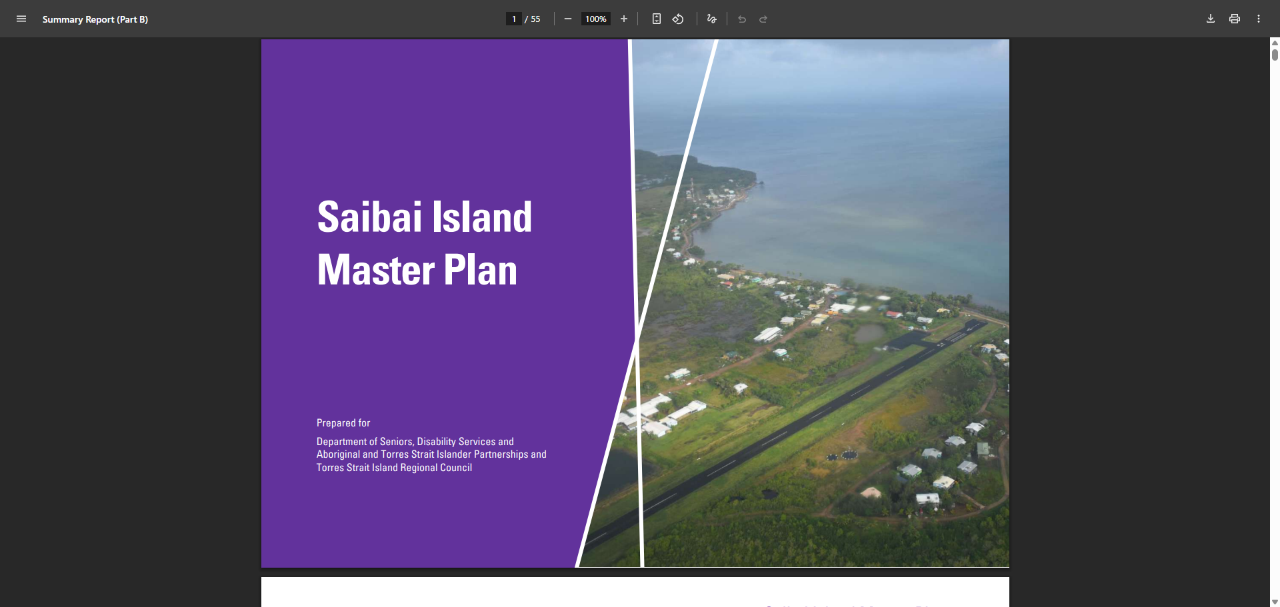

**EWB Challenge**

图形用户界面, 文本

AI 生成的内容可能不正确。

**Engineers Without Borders Australia** 图形用户界面

AI 生成的内容可能不正确。

**Torres Cape Indigenous Council Alliance** 截图里有图片

AI 生成的内容可能不正确。

**House of Representatives Standing Committee on Indigenous Affairs.** 图形用户界面, 文本, 应用程序

AI 生成的内容可能不正确。

**National Indigenous Australians Agency** 图形用户界面, 文本, 应用程序

AI 生成的内容可能不正确。

**Bureau of Meteorology**

图形用户界面

AI 生成的内容可能不正确。

**Department of Agriculture, Fisheries and Forestry.** 电脑屏幕截图

AI 生成的内容可能不正确。

**Ergon Energy. (n.d.). *Isolated & remote power stations*.** 图形用户界面

AI 生成的内容可能不正确。

**Australian Energy Regulator** 图形用户界面, 文本, 应用程序

AI 生成的内容可能不正确。

**CHOICE** 图形用户界面, 文本, 应用程序, 电子邮件

AI 生成的内容可能不正确。

**ABC News** 